**NAME: ALEENA SAEED**

**COURSE TITLE: COMPUTER ARCHITECTURE**

**DEPARTMENT: BSCS-4**

**SAP ID: 56270**

**WEEK-4**

**TASK 1**

**NAND Gate Using Switches**

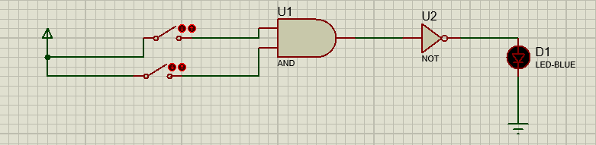

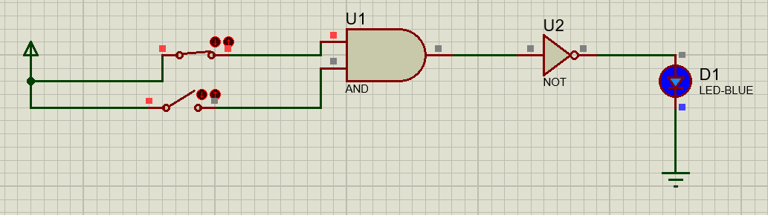

**TASK 2**

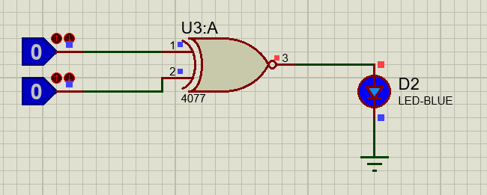**XNOR Gate**

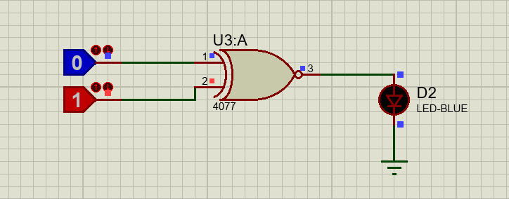

**TASK 3**

**Half Subtractor**

